CSE 220 Data Structures - Quiz 01
B
Date: 26 February 2025
Time: 30 minutes

Name: ID:

- Draw the final Singly Linked List after performing the following sequence of operations. Assume that the initial list is: 25 → 15 → 40 → 30 [5 marks]
  - remove(index = 3)
  - leftRotate(5)
  - insert(index = 2, element = 45)
  - rightRotate(5)
  - leftRotate(8)
After a: 25 → 15 → 40
After b: 40 → 25 → 15 leftRotate(5) = leftRotate(5%3) = leftRotate(2)
After c: 40 → 25 → 15 → 45
After d: 45 → 25 → 15 → 40 rightRotate(5) = rightRotate(5%4) = rightRotate(1)
After e: 45 → 25 → 15 → 40 leftRotate(8) = leftRotate(8%4) = leftRotate(0)
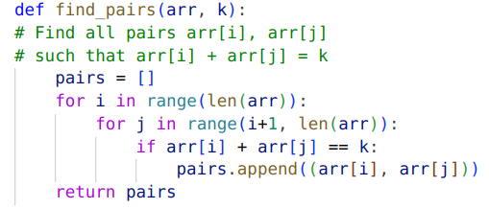
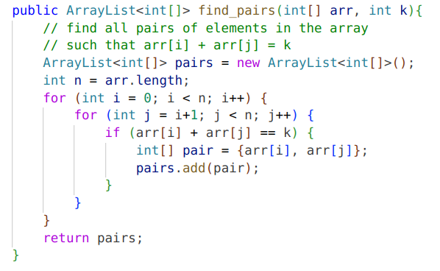
- Find the time and space complexity of the following code snippet: [5 marks]
Python Java
Write your answer below
Time complexity: O(n^2)
Space complexity: O(n^2) ⇒ number of possible pairs are approximately (n^2)/2
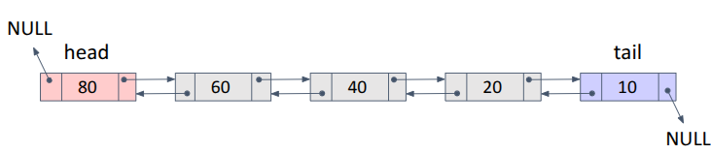
- You are given a doubly linked list, and your task is to insert a new node with the value 80 at index 3. The insertion should follow the correct sequence of operations. Below is a list of steps, but they are not in order. Rearrange them correctly to complete the insertion process. [5 marks]
  - Set previous.next = newNode
  - Set newNode.prev = previous
  - Find the previous node before the insertion position
  - Set newNode.next.previous = newNode
  - Create a new node with the element 80
  - Set newNode.next = previous.next

Write the correct sequence of operations (a,b,c,d,...) in the table below

1 | 2 | 3 | 4 | 5 | 6
e | c | b | f | d | a

Time complexity: O(n)

Multiple valid orderings are possible. As long as you don’t break the list, you can perform the operations in any valid order. It’s best to connect the newNode with the list first, then connect the list with the newNode. That way, you have less risk of breaking the list.

